Probability and Random Variable Exercises

Stephen Blatti

October 17, 2017

3.3 How many different six-place license plates are possible (first two places letters, remaining places numbers) if repetition among letters and numbers is not permissible?

(26 * 25) * (10 * 9 * 8 * 7)

## [1] 3276000

3.5 A hat contains 20 consecutive numbers (1 to 20). If four numbers are drawn at randomd, how many ways are there for the largest number to be a 16 and the smallest number be a 5?

choose(10,2)

## [1] 45

# There is only one way for the smallest number to be a 5 and the largest number to be a 16.  
# Then we have two numbers to be drawn between the 6 and 15. So the remaining two numbers can be selected by choose(10,2)

3.7 How many different letter arrangements can be made from the letters BIOLOGY, PROBABILITY, and STATISTICS, respectively.

factorial(7) / factorial(2)

## [1] 2520

factorial(11) / ( factorial(2) * factorial(2) )

## [1] 9979200

factorial(10) / ( factorial(3) * factorial(3) * factorial(2) )

## [1] 50400

3.9 A shipment of 50 laptops includes 3 that are defective. If an instructor purchases 4 laptops from the shipment to use in his class, how many ways are there for the instructor to purchase at least 2 of the defective laptops?

choose(47, 2) * choose(3, 2) + choose(47, 1) * choose(3, 3)

## [1] 3290

3.11 How many ways can five politicians stand in line? In how many ways can they stand in line if two of the politicians refuse to stand next to each other?

factorial(5)

## [1] 120

factorial(5) - 2 * factorial(4)

## [1] 72

3.13 A president, treasurer, and secretry, all different, are to be chosen from among the 10 active members of a university club. How many different choices are possible if (a) There are no restrictions. (b) A will serve only if she is the treasurer. (c) B and C will not serve together. (d) D and E will sersv together or not at all. (e) F must be an officer.

a = 10 * 9 * 8  
b = 9 * 8 * 7 + 9 * 8  
c = 8 * 7 * 6 + 3 * 2 * 8 * 7  
d = 8 * 7 * 6 + 3 * 2 * 8  
e = 3 * 9 * 8  
c(a,b,c,d,e)

## [1] 720 576 672 384 216

3.15 Suppose four balls ate chosen at random without replacement from an urn containing six black balls and four red balls. What is the probability of selecting two balls of each color?

choose(4, 2) * choose(6, 2)/choose(10, 4)

## [1] 0.4285714

3.19 In the New York State lottery game, six of the numbers 1 through 54 are chosen by a customer. Then, in a televised drawing, six of these numbers are selected. If all six of a custmer's numbers are selected, then that customer wins a share of the first prize. If five or four of the numbers are selected, the customer wins a share of the second or the third prize. What is the probability that any customer will win a share of the first prize, the second prize, and the third prize, respectively?

choose(6, 6) / choose(54, 6) # Pr(first prize)

## [1] 3.871892e-08

choose(6, 5) * choose(48, 1) / choose(54, 6) # Pr(second prize)

## [1] 1.115105e-05

choose(6, 4) * choose(48, 2) / choose(54, 6) # Pr(third prize)

## [1] 0.0006551242

3.51 Consider the folowing function:

$$f(x)=2/25*(x−5),5<=x<=10$$

. a) Show that f(x) satisfies properties 1 and 2 page 93 of a continuous probablity density function.

f <- function(x){2/25*(x - 5)}   
integrate(f, 5, 10)$value

## [1] 1

1. Plot f(x)

curve(f, 5, 10)

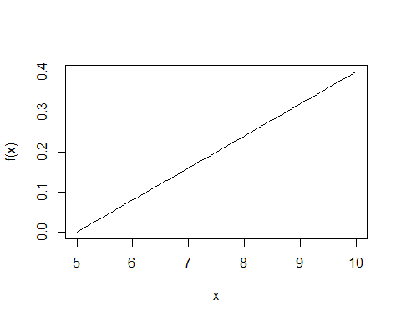

1. Derive and plot f(x)'s cummulative probablity function, F(x).

$$F(x)=\int_{5}^{x}{2}/25*(y−5)dx=(x−5)^{2}/25$$

F <- function(x){(x - 5)^2/25}   
curve(F, 5, 10)

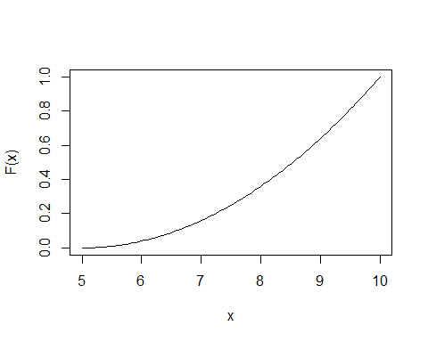

1. Calculate P(X <= 8), P(X >= 6), and P(7 <= X <= 8).

F(8)

## [1] 0.36

1 - F(6)

## [1] 0.96

F(8) - F(7)

## [1] 0.2

1. Calculate P(X <= 8), P(X >= 6), and P(7 <= X <= 8) using the function integrate().

integrate(f, 5, 8)$value # P(X <=8)

## [1] 0.36

integrate(f, 6, 10)$value # P(X >=6)

## [1] 0.96

integrate(f, 7, 8)$value # P(7 < X < 8)

## [1] 0.2

3.53 Define X as the space occupied by certain device in a 1 $m^{3}$ container. The probablity density function of X is given by

$$f(x)=(630/56)*x^{4}(1−x^{4}),0<x<1.$$

a) Graph the probability density function

f <- function(x){630/56*x^4*(1-x^4)}   
curve(f, 0, 1)

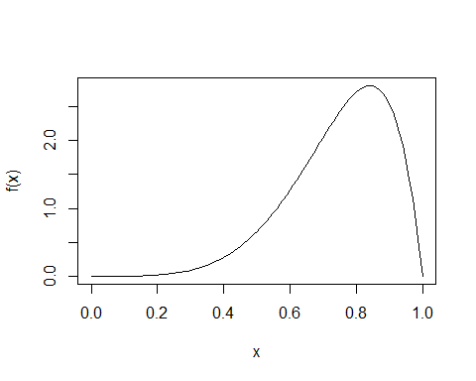

1. Calculate the mean of X using integrate().

fx <- function(x){x * f(x)}  
EX <- integrate(fx, 0, 1)$value  
EX

## [1] 0.75

1. Calculate the variance of X using integrate().

fx2 <- function(x){x^2 * f(x)}   
EX2 <- integrate(fx2, 0, 1)$value  
VX <- EX2 - EX^2  
VX

## [1] 0.02191558

1. Calculate P(0.20 < X < 0.80) using integrate().

integrate(f, 0.2, 0.8)$value

## [1] 0.5687885